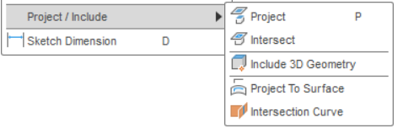

Project / Include Tutorial

Preface: it gets really janky when you’re trying to project / intersect things onto a 3D sketch.

# Project

Example

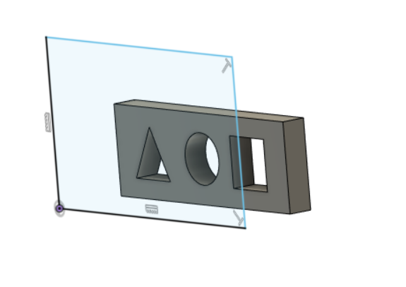

Mkay let’s say you have this box that you just want to be projected on the current sketch you’re working on

You can use the “project” tool to take parts of the sketch and put it into the current one you’re working on:

You can project whole faces:

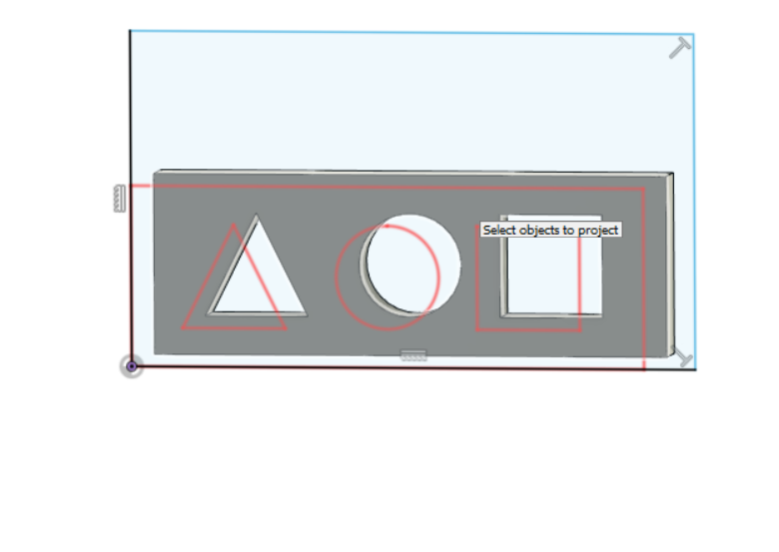

Or lines:

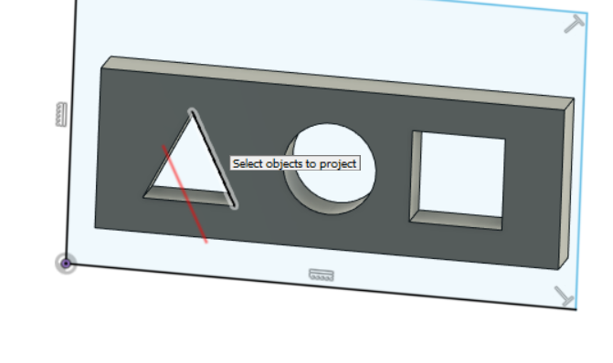

Or points:

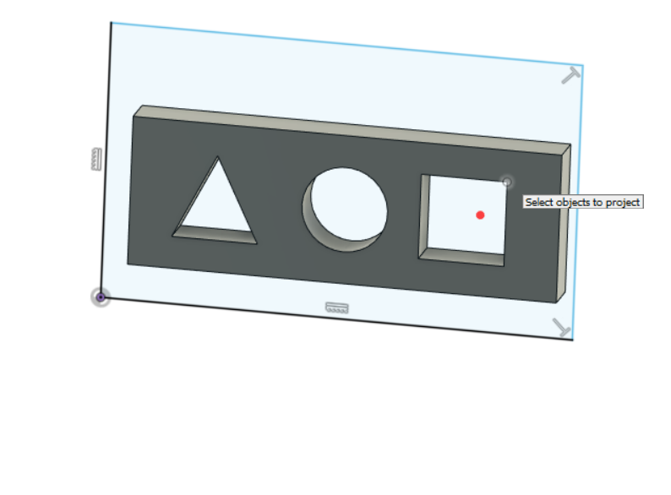

Say I just wanted the box, it would look like this: 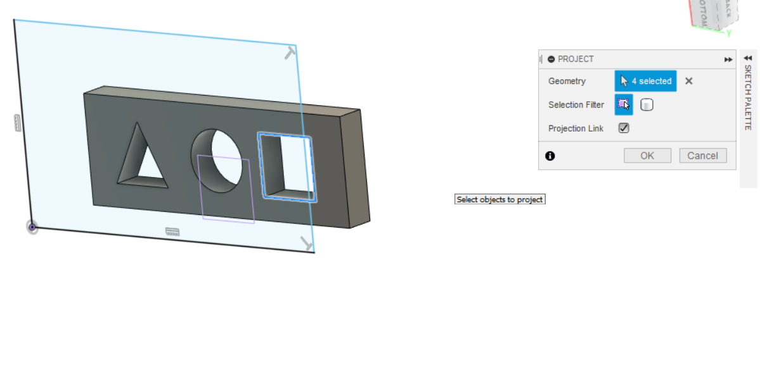

Info:

* If you update the box it will update the project, until it does something drastically different than what was originally there.

Ex. if I change the box to 2.5 in across it simply increases it:

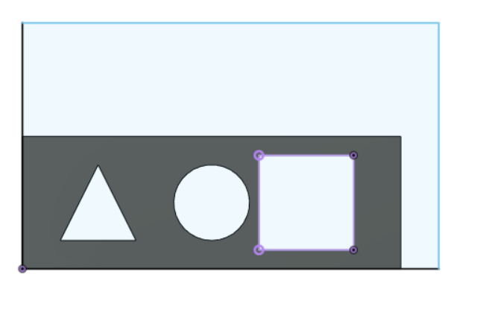 → 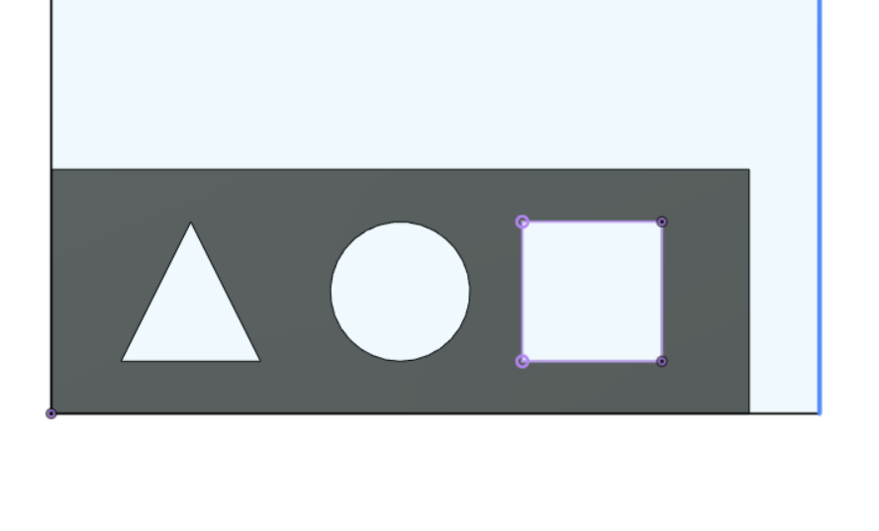

However, as soon as I do something drastic, like have it cut into the circle, it’ll break:

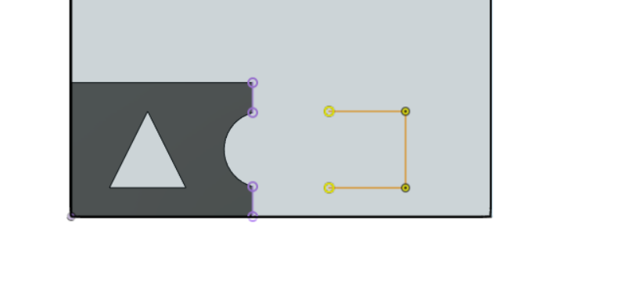

Yellow: projected lines that are broken.

Tip: Project also works for tilted planes.

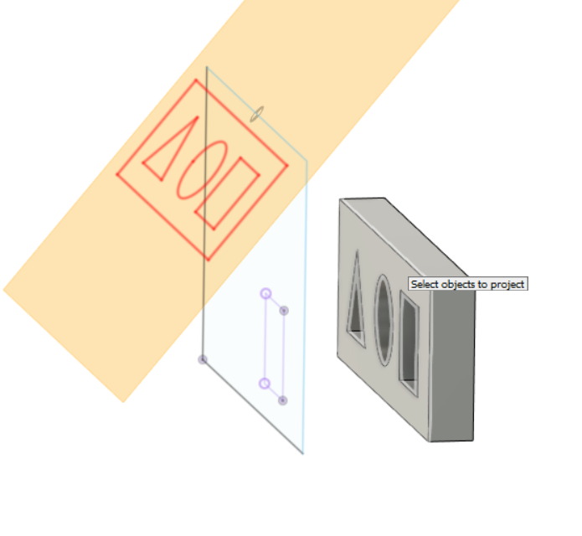

# Intersect

Hehe we’re gonna use an FCA example for this one: